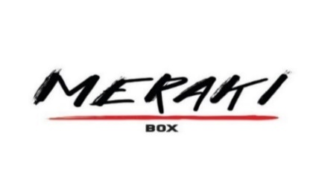

**Saturday October 7, 2023, at 10:00 AM-12 Noon**

**LOCATION:** **Meraki Box – 1727 West Main St., Suite #1 Rapid City SD**

**Your physical wellbeing is a combination of physical, mental and spiritual.**

Push your endurance working out and help make a difference in our community. Be a Warrior for Esther’s Rising!

**What to expect:** A cardio/core workout tailored to your individual conditioning, targeting physical, mental, and spiritual wellbeing! The coaches at Meraki Box/GF Ministries will train you in a unique setting designed specifically for this class. Weaving exercise and God’s word, challenge yourself to a new experience, and help make a positive impact in our communities!

**Who should attend:** Men/Women/Teens who want to be a difference in this world by bettering themselves. Understanding that collectively, we can do great things together!

**What is GF Ministries:** A Christian ministry that is devoted to bringing the principles taught by Jesus Christ into the lives of people in a non-traditional church setting, allowing people to grow to their full potential. We are not a church; you will not be asked to join any organization.

**What will I need:** If you’re able to donate to please help support **“Esther’s Rising”,** that is your camp fee! Consider possibly getting friends/family to sponsor you in this workout for a great cause! Gym clothes, shoes, towel, etc as you will experience a full workout to your individual capability. Most importantly an open heart, willing to be challenged, so we each can grow in our journey to fulfill our purpose and help others in doing so.

**Register early to help with our planning! Light lunch provided after the workout.**

**Register by email:** [**gfminitries@gmail.com**](mailto:gfminitries@gmail.com)**; by Text/phone (518) 491-7295, or**

**In person at Meraki Box**